Autumn 2018 Newsletter
Environmental & Development Industry News
Land-clearing Code declared invalid
The Land and Environment Court of New South Wales has declared the Land Management (Native Vegetation) Code 2017 (‘Code‘) made under the Local Land Services Act 2013 (‘LLS Act‘) to be “invalid and of no effect”.
From 25 August 2017, when the Code was first introduced, landholders were required to use the Code in order to self-assess whether or not clearing required approval before being undertaken.
As a result of the Court’s decision, the lawfulness of any clearing of native vegetation on regulated land and undertaken in compliance with the requirements of the Code as it was thought to be, since 25 August 2017, could potentially be in doubt.
The Government will presumably seek to remake the Code after following the requirements of s60T.
http://www.lindsaytaylorlawyers.com.au/in_focus/index.php/2018/03/alert-land-clearing-code-declared-invalid/#.WsXMsGZf2Uk

EPA Act Amendments – An update on building information certificates
The NSW Government has now amended the Environmental Planning and Assessment (Savings, Transitional and Other Provisions) Regulation 2017 (Savings Reg), so that it clearly states that the new building information certificate provisions are in force.
The Amending Regulation has inserted words to clause 18(2) of the Savings Reg, that specify that Division 6.7 of the EPA Act (that deals with building information certificates), applies, and is not postponed to 1 September 2018.
The amendments removes doubt and ensures that Councils can issue building information certificates with certainty.
http://www.lindsaytaylorlawyers.com.au/in_focus/index.php/2018/03/epa-act-amendments-an-update-on-building-information-certificates/#.WsXOk2Zf2Uk

Court refuses proposal to dedicate land in lieu of s94 monetary contributions
In the recent case of McCloy Teralba v Lake Macquarie City Council [2017] NSWLEC 1752 the Land and Environment Court refused to allow a development consent to be modified under s96 of the Environmental Planning and Assessment Act 1979 (‘EPA Act‘) by replacing a condition imposed under s94(1) of the EPA Act requiring the payment of a monetary contribution to the Council for open space with a condition requiring the dedication of land free of cost to the Council as public open space. The appeal was brought from a deemed refusal of the application by the Council.
http://www.lindsaytaylorlawyers.com.au/in_focus/index.php/2018/02/court-refuses-proposal-to-dedicate-land-in-lieu-of-s94-monetary-contributions/#.WsXPUWZf2Uk

EDAP Western Group Conference 2018 – Mudgee 11-13 April 2018
The 18th EDAP Western Group Conference incorporating the 69th Western Group Regional Conference will be held at the Parklands Resort and Conference Centre, Mudgee, on 11-13 April 2018. Come along for a catch-up and to hear the latest on regional health and development issues. Members are encouraged to stand for the EDAP committee with our AGM to be held at the conference.
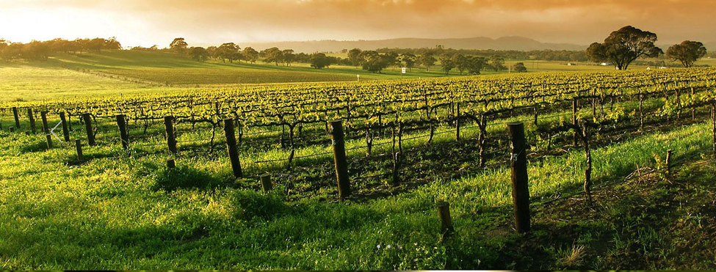
Parklands are offering a discount for delegates choosing to stay at the conference venue. The Promotion Code for delegates booking accommodation at Parklands is PRMPROMO. Contact Parklands direct on 6372 4500 or via www.parklandsresort.com.au

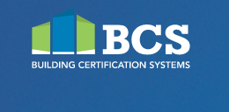

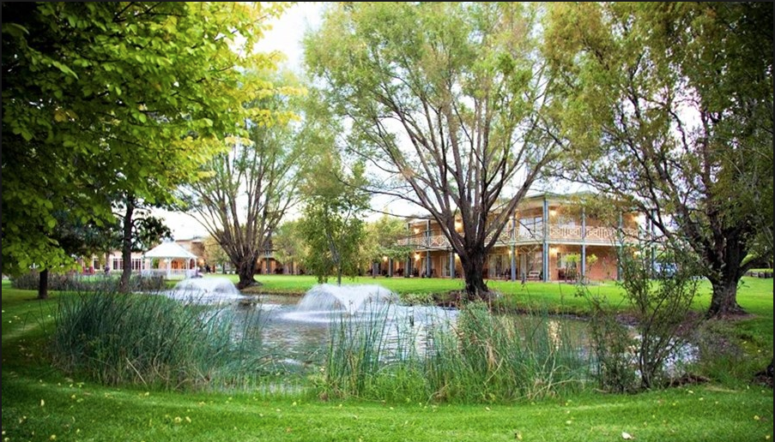
Above: Parklands Resort and Conference Centre in Mudgee
Below: Mudgee Brewing Company – a great place for breakfast or beer

EDAP Membership
EDAP membership now at 534

Golf anyone?
EDAP is considering holding an annual golf day. This will be discussed at the AGM so let us know your thoughts.

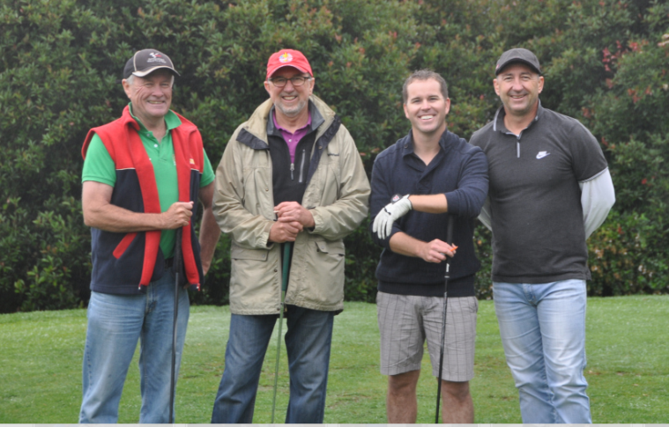
Above: Team EDAP blitzed the field at the DEPA Golf Day in 2015.

Upcoming Training & Conferences
- EDAP is partnering with the Association of Accredited Certifiers (AAC) to deliver a trainee-specific conference titled “New Certifiers on the Block”. This conference will be held at the Carrington Hotel, Katoomba, on Friday 10 August 2018.
- Hands-on inspection techniques - a practical day at Dubbo in conjunction with Procert. Date TBA
- Health training with Jeff Byrom. Date and venue TBA
- AAC Conference 2018 – Great Expectations. To be held Friday 25 May 2018 at The Star Event Centre, Pyrmont
- Australian Institute of Building Surveyors (AIBS) Conference to be held 2 & 3 July 2018 at the International Convention Centre, Sydney.
- Environmental Planning & Law Association (EPLA) to be held 25 & 26 October 2018 at Q Station, Sydney Harbour National Park, Manly.

Baby News
Mat & Annalise Teale have just had their second baby - a little girl! Abigail “Abby” Lesley Teale

Fundraising for blood cancer research
EDAP encourages members to support the “Buzz Cute Beauties” who are having their heads shaved to raise funds for blood cancer. This fundraiser is being organised by EDAP member Kristy McCreadie. See Kristie if you’d like to lend your support.

