2019 EDAP REGIONAL CONFERENCE BOURKE WRAP-UP

The recently held Bourke EDAP Conference attracted over 70 delegates from Corowa to Broken Hill for the 19th EDAP Regional Conference hosted by Bourke Shire Council with some of the highlights of the conference being:

- A large roll up of delegates from the Far North Western and Western group for the Wednesday Regional Food Group meeting and training held at the new Bourke Shire Council Back O’Bourke Conference Centre and chaired by Jeff Byrom and with Ruth Endicott and Judd Owen from the NSWFoodAuthority

- The Port O’ Bourke Hotel hosted the Wednesday evening welcome drinks and dinner sponsored by B.E.S.T. with over 50 delegates attending this welcome function

- Thursday morning delegates registered at the new Bourke Shire Council Back O’ Bourke Conference Centre at the Back O’ Bourke Exhibition Centre

- The conference was opened by Bourke Shire Council Mayor Clr Barry Holman who provided an in depth presentation of the area which was followed by Mrs Jodi Sontag Manager of Bourke Shire Councils Tourism and local artist Jenny Greentree who both provided us with a from the heart presentation of the resilience of the locals through floods and drought of the area and boom and bust times.

- At the conclusion of presentations and due to the current drought conditions the Jandra Paddle Steam boat was grounded. So a tour of the Back O’ Bourke Exhibition Centre was organised by Bourke Shire Council for the delegates which gives an in depth history of Bourke and surrounds.

- Thursday evening delegates returned to the Back O’ Bourke Exhibition Centre for the Conference dinner which was a camp oven Mulliga and Curried Sausages provided by the local fishing club Bourke Aint Caught Nuffin Fishing Club.

- Pre-dinner canapés and desert were provided by Bourke High School Hospitality students as were the lunches and morning and afternoon teas during the conference and they were superb

- Background music was provided by local” Gordo”

- Some special presentations were made during the evening to:

Mr Steven Campbell retiring from Parkes Shire Council,
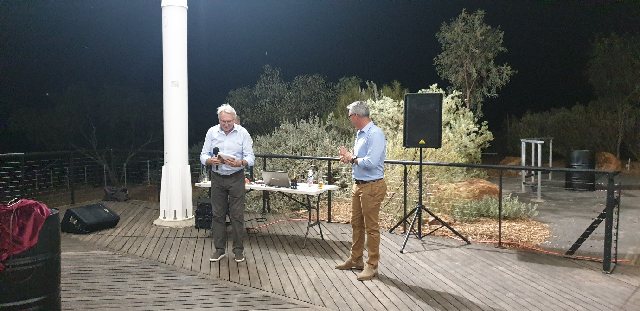
Mr Gary Green of Pikes Verekers Lawyers, 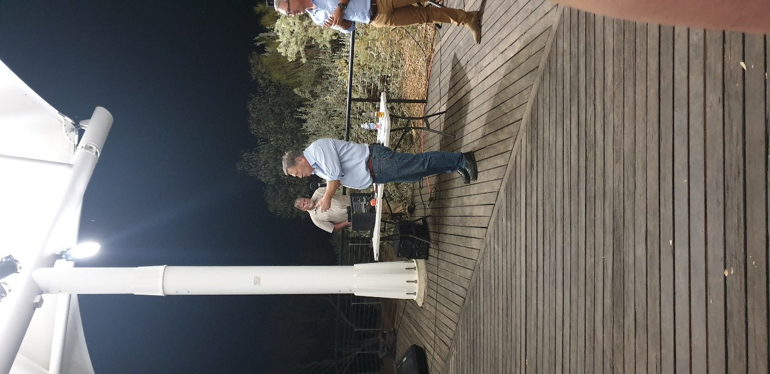

Mr Brent Livermore of B.E.S.T. retiring, and

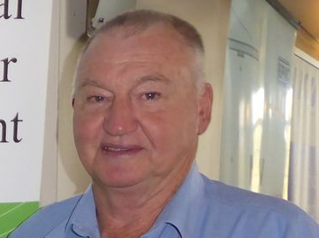

Steve Gordie of the Bourke Aint Nuffin Fishing Club was presented with a donation from EDAP. This fishing club puts everything back into the Darling River and EDAP’s donation will ensure fingerlings are provided to the river

- Friday saw delegates travel out to Byrock to visit the Byrock Water Holes a spiritual aboriginal place and local Elder Phillip Sullivan provided delegates with not only a tour of the area but also some very important messages to take back home with them.

- Delegates then enjoyed a hearty brunch at the Mulga Creek Hotel before there long journey back home

- At the EDAP AGM the committee for 2019/2020 as elected are:
President; Brendan Hayes
Secretary/Treasurer; Alan Lindsay
Public Officer: Steven Campbell
Membership: Isabel Holmes
Newsletter; Murray Amos
Committee: Jeff Byrom, Erika Mackenzie Mark Robertson, Mark Hodges and Travis Stewart
- The Twentieth (20TH) EDAP Regional Conference is to be hosted by Orange City Council in 2020, the twenty first (21st) Conference by Gilgandra Shire Council in 2021 and 2022 by Blayney Shire Council.

UPCOMING CONFERENCES
- Association Accredited Certifiers (AAC)Friday 7 June 2019

AIBS New South Wales / Australian Capital Territory Chapter Conference | 22 - 23 July 2019
International Convention Centre, NSW
- Environmental Health Australia (EHA) NSW Conference and NSW Food Authority FRP Workshop QStation Manly 19 to 23 August 2019

- AAC/EDAP New Certifiers on the Block Friday 25 October 2019 Carrington Hotel Blue Mountains
- EPLA Conference October 2019 dates & venue tba
